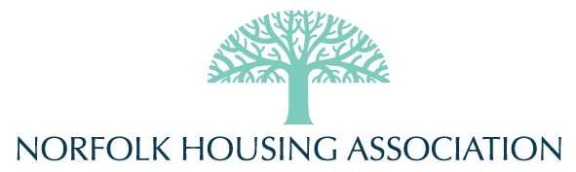

Community Advisory Group Agenda & Notes
MEETING: 09 March, 2021, 6-8pm
Agenda
Notes in Blue
- Meeting Opening (10 minutes)
  - Introductions of everyone on the call
  - Welcome & Respectful Communication Policy
  - Brief overview of agenda
- Operations & Buildings (20 minutes)
  - Building updates
Notes: Concrete at Gayner, Bowen, and Riley. Riley used to have a step that was impeding accessibility, so now there is a ramp (as well as accessible doors). Still to come: accessibility railings. At Gayner, the sidewalk out front was uneven and difficult to navigate with a walker and such. Bowen was similar. So those are being levelled and improved to increase safety. Riley also got new balcony railings and surface coating on the balconies. Throughout all the buildings, we will be replacing lights to LED and appropriate fixtures to match.
There will be some major work at Norfolk House in the next while, including lighting, flooring, and painting in common areas.
All buildings are getting in unit upgrades such as counters and flooring as necessary, based on our suite inspections.
Can we get the intercoms at Bowen (and Gayner) put on the outside? Because we do have people starting to sleep in the doorways again. Maintenance staff is looking at how to get the intercoms outside, as they are at the other buildings.
Concerns around the safety of the courtyard at Pemberton, because sometimes people in and around the area looking for bikes and other things and it’s not safe, especially for the kids in the building. It’s become a bigger problem in recent weeks/months. Some ongoing concerns around parking lot safety at Bowen as well.
  - Accessibility and aging in place
Notes: Are hand railings in showers able to be installed more often, for more people? It’s a liability issue in terms of maintenance staff implementing them, so we partner with Accessible Housing to ensure those types of items are installed correctly. Co-op also has some great, affordable options, including help with grants, and installation. (Let’s add this info to the next newsletter)
  - Related questions from residents
- Communications and Events (30 minutes)
  - Calgary Dollars Initiatives
Notes: Lots of ongoing initiatives, right now the theme of workshops and webinars is food security. Upcoming workshop on canning and preserving, and residents can use C$ to buy a kit and participate fully.
  - Upcoming resident survey (accessibility)
Notes: The resident survey is coming in January and there will be questions on what residents need in the coming years around accessibility and resources.
Do we need to consider fire alarms that include lights, to improve accessibility for people with hearing difficulties. Mobility is another consideration, even if it’s not an aging situation, but rather a health-related one. These types of situations can be temporary and/or become permanent.
Starting next month, residents will have a move-in report that they can share any accessibility needs or special considerations with the team. Norfolk is always willing to adjust lighting, alter fire alarms, or do what is necessary to keep residents safe and feeling at home and this should help ensure that those needs are being met from the start. Current residents can always contact the office with changing needs and requirements. Staff are committed to doing what they can to ensure the safety and comfort of all residents.
How can we help neighbours who need certain kinds of supports in home? Best thing to do is contact Liz or Charlaine in the office to work with that resident to sort out what resources and options are available to Albertans/Calgarians.
This would be a great item to have a more in depth conversation about at next CAG meeting in January.
  - Related questions from residents
- Resident Led Ideas & Questions (15 minutes)
  - Any questions or concerns not of a personal nature
- Closing remarks (15 minutes)
  - Items for next CAG meeting
  - Thank you for attendance

